Assignment 7: - Agile User Stories, Product Backlog, Sprint Backlog and Burndown Chart(Tools: Jira/Trello).

Goal of the System
The goal of the Fire and Gas Detection System with ML-based Fault Detection is to monitor environmental conditions using sensors, detect fire and gas leaks in real-time, and identify system faults using machine learning. The system provides alerts, logs, and dashboard visualization for effective monitoring and safety.

🔹 Step 1 — System Actors
- User (System Operator)
- Admin
- ESP32 Device
- ML Prediction System

🔹 Step 2 — Agile User Stories (FROM YOUR BOARD)
ID | User Story
US1 | As a user, I want to login so that I can access the system
US2 | As a user, I want to view dashboard so that I can monitor system status
US3 | As a user, I want to view logs so that I can analyze system activity
US4 | As a user, I want to filter logs so that I can find errors easily
US5 | As a system, I want to run ML prediction so that faults are detected
US6 | As a user, I want to view alerts so that I can respond quickly
US7 | As a user, I want to view reports so that I can analyze performance

🔹 Step 3 — Story Points (MATCH YOUR BOARD)
User Story | Feature | Story Points
US1 | Login to system | 2
US2 | View dashboard | 3
US3 | View logs | 3
US4 | Filter logs | 2
US5 | Run ML prediction | 5
US6 | View alerts | 3
US7 | View reports | 3
Total = 21 Story Points

🔹 Step 4 — Product Backlog (Prioritized)
Priority | Feature | Story Points
1 | Login system | 2
2 | View dashboard | 3
3 | View logs | 3
4 | Filter logs | 2
5 | Run ML prediction | 5
6 | View alerts | 3
7 | View reports | 3

🔹 Step 5 — Sprint Backlog (YOUR ACTUAL STATUS)

🟢 Sprint Duration: 2 Weeks

🟢 Sprint Velocity: ~20 Story Points

🔹 Completed (DONE column)
Task | Points
Login to system | 2
View system logs | 3
View dashboard | 3
Total Completed = 8 SP

🔹 In Progress
Task | Points
Filter logs | 2
View alerts | 3
Total = 5 SP

🔹 To Do
Task | Points
Run ML prediction | 5
View reports | 3
Total = 8 SP

🔹 In Review
Task | Points
Dashboard & Reports | —

🔹 Step 6 — Task Breakdown Example

Example: Log Monitoring System
Task | Hours
Log data display | 5
Filtering logic | 6
UI integration | 4
Testing | 4
Total = 19 Hours

🔹 Step 7 — Jira Implementation

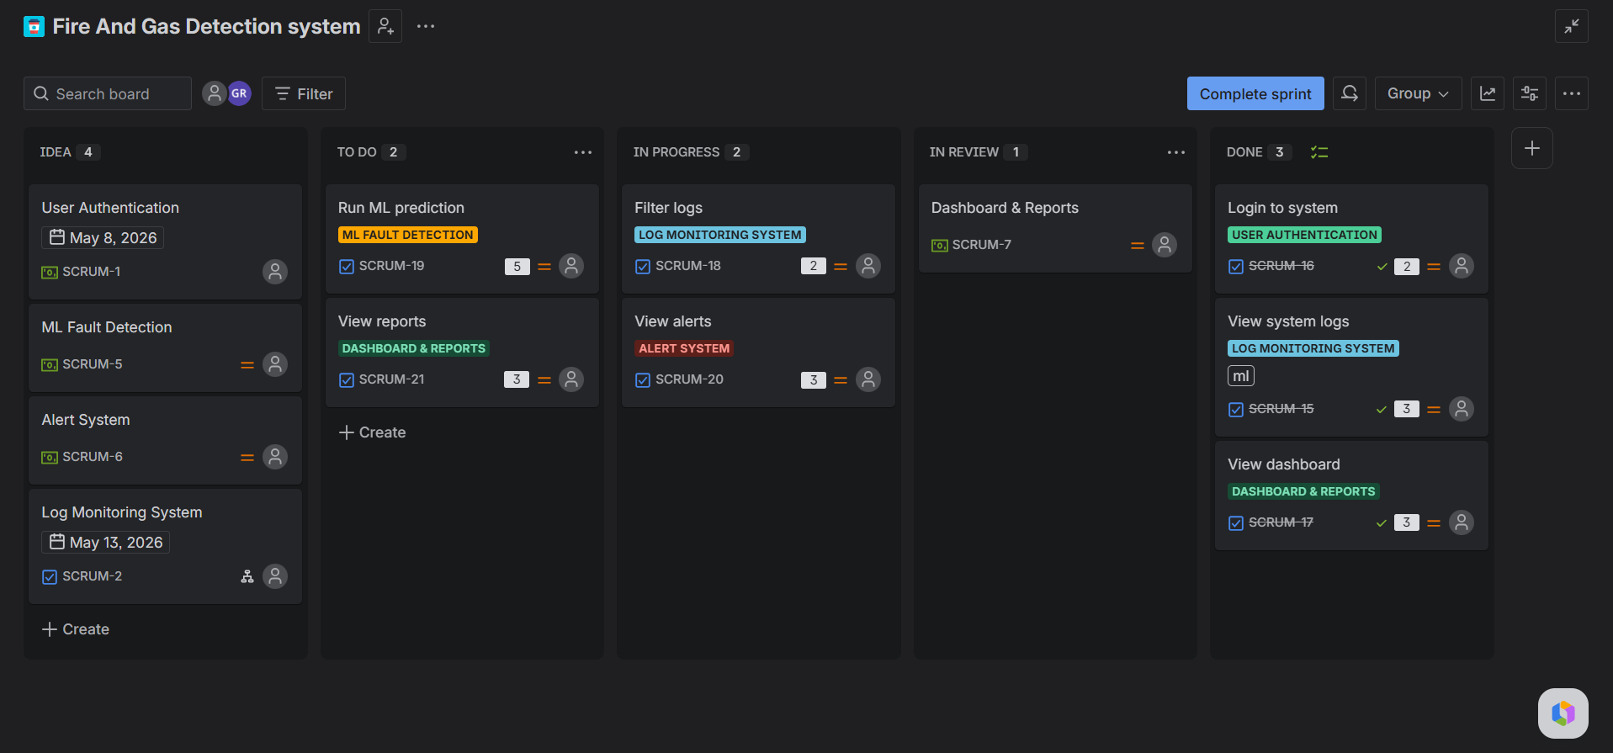

🔹 Step 8 — Burndown Chart Data

Total Story Points = 21
Day | Remaining
Day 1 | 21
Day 2 | 19
Day 3 | 17
Day 4 | 14
Day 5 | 12
Day 6 | 10
Day 7 | 8
Day 8 | 5
Day 9 | 3
Day 10 | 0

🔹 Burndown

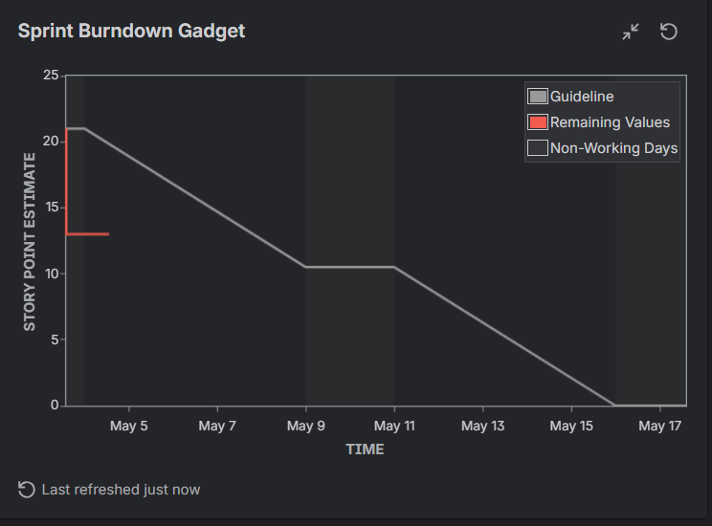

🔹 Conclusion
Agile Scrum methodology was effectively applied to the Fire and Gas Detection System. Jira enabled structured task tracking and sprint monitoring. The system was developed incrementally, ensuring better visibility, faster feedback, and efficient delivery of features.

